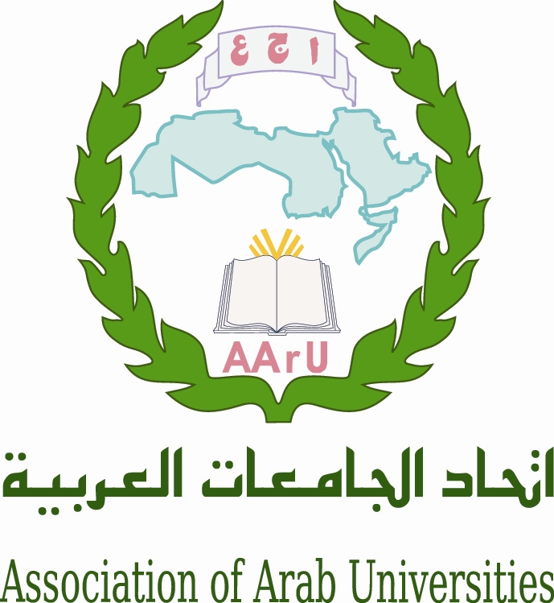

Governing Board Meeting of the Euro-Mediterranean Universities Network TETHYS

Association of Arab Universities

With the support of the Embassy of France

2nd of april 2015

STRENGTHENING of RELATIONS Between HIGHER EDUCATION
and the WIDER ECONOMIC and SOCIAL ENVIRONMENT

University-Enterprise Cooperation, Entrepreneurship and Employability of Graduates

Venue : Headquarter of the Association of Arab Universities, 11941 Jubeyha, Amman, Jordan

Thursday 2 april

8h30-9h00 Registration of participants

9h00-9h30 M. Sultan Abu-Orabi, Secretary General of Association of Arab Universities
M. Michel Kasbarian, Honorary President of Tethys, Aix-Marseille University Representative

Institutional Authorities:
Mme l’Ambassadrice de France, French Embassy
M. Ministry of Education and Research of Jordan

9h30-10h30 Roundtable 1 : University-Enterprise Cooperation

Moderator : M. (University, enterprise ?)

Mrs Marie Odile Ott, (French Ministry IGAENER), “Making university-industry partnerships work: trials and lessons”

M. XX (Jordan Chamber of Industry)

10h30-11h00 Coffee break-Networking

11h00-12h30 University-Enterprise Cooperation - Entrepreneurship

Moderator: M. (university, enterprise ? )

M. Tarak Tabbaa (Amman Chamber of Commerce)

M. Jean Louis Gouju (French Ministry Dir. Gén. Enseignement Supérieur et Insertion Professionnelle)

M. XX ( Jordanian Pharmaceutical Manufacturing Co)

12h30-14h00 Lunch

14h00-16h45 Roundtable 2 : Entrepreneurship - Employability of graduates

14h00-15h00 Moderator : M. (University, industry, AARU ?)

Mrs Decroix-Taffet (Aix-Marseille University),“Boosting Employment thanks to Entrepreneurship Education?"

M. Antoine Hokayem (Saint Joseph University) “links between graduates’ skills and employability”

15h00-15h15 Coffee break-Networking

15h15-16h45 Employability of graduates

Moderator : M. (University, industry, AARU ?)

M. Mohamed Nemamcha (University of Guelma) “state of the art in Algeria”

M. Mohamed Belhaj (University of Sfax), “new looks on the role of Tunisian universities on professional insertion of graduates”

M.

16h45-17h00 Conclusion and closing session

M. Mohamed Rafat Mahmoud (AARU)

***********************

Contacts: Ms May Wahbeh: may@aaru.edu.jo ; M. Mahmoud Rafat: rafat@aaru.edu.jo

Ms. Lila Hachemi : lila.hachemi@univ-amu.fr; M. Michel Autric : michel.autric@univ-amu.fr

