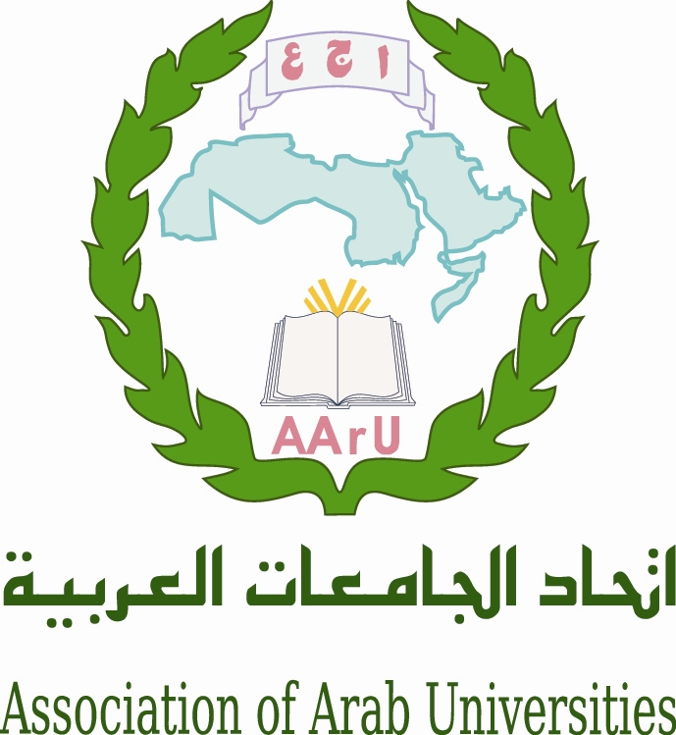
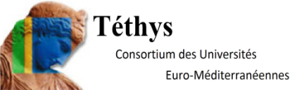

Governing Board Meeting of the Euro-Mediterranean Universities Network TETHYS

Association of Arab Universities

With the support of the Embassy of France

1st of april 2015

Venue : Headquarter of the Association of Arab Universities, 11941 Jubeyha, Amman, Jordan

Pre-Programme

Wednesday 1 april

12h00-13h00 Registration of Participants

13h00-14h00 Lunch

14h00-14h15 Welcome speeches

M. Sultan Abu-Orabi, Secretary General of Association of Arab Universities
M. Michel Kasbarian, Honorary President of Tethys, Aix-Marseille University

14h15-18h00 Governing Board meeting

Moderators: M. Rafat Mahmoud (AARU),
M. Michel Autric (Aix-Marseille University)

14h15-14h45 Presentation of the Association of Arab Universities

14h45-15h30 Presentation of European Programmes and Strategy

M. Jacob Arts, Programme Manager, Delegation of the European Union to Jordan
“The EU Framework programme for Research and Innovation, H 2020”

M. Ahmad Abu-El-Haija, Director, National Erasmus + Office Jordan
“The EU Erasmus + programme and its International Dimension in Higher Education ”

15h30-16h00 Coffee break

16h00-17h00 Evaluation of activities
Proposal for collaborations and new shares
Perspectives 2015/2016

17h00-17h45 Presentation/welcome of new partners

17h45-18h00 Candidate for next board 2015
Various questions
End of the Board

20h00 Gala Dinner hosted by AARU (venue ?)

