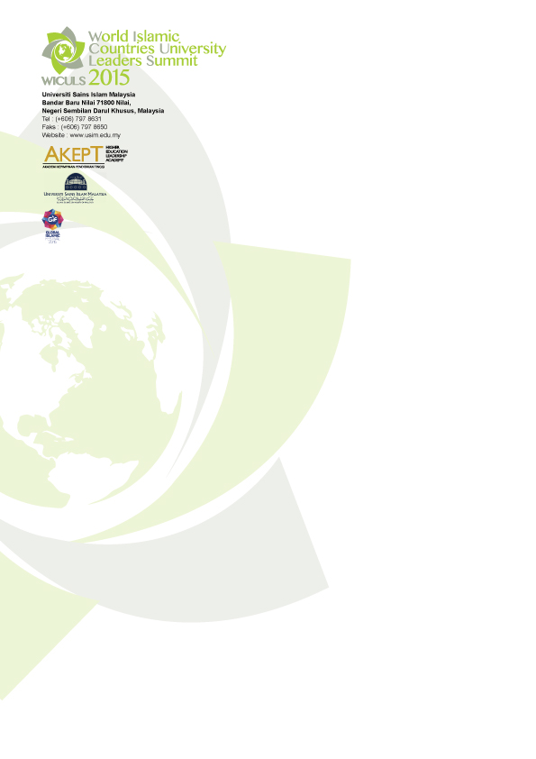

WORLD ISLAMIC COUNTRIES UNIVERSITY LEADERS SUMMIT
(WICULS 2015)

29-30 September 2015
Hotel Marriott, Putrajaya

Organised by
Higher Education Leadership Academy (AKEPT)
Universiti Sains Islam Malaysia (USIM)

WORLD ISLAMIC COUNTRIES UNIVERSITY LEADERS SUMMIT 2015 – WICULS 2015
Overview

The rapid changing landscape of tertiary education in the world today requires university leaders who can respond positively to these changes. This relates to their prudence to re-examine the current worldview, direction, scope of change that could lead to the appropriate action and function of their universities as the seat of scholarship and citizenry in addressing future concerns. This must take on the context of education for the Muslim ummah that is closely aligned to the understanding of the philosophy of learning in Islam. Universities in Islamic countries and leadership need to play a multifaceted and proactive role to bring peace in the Muslim communities mediate conflict resolutions and promote internationally agreed accords for a common platform to craft long term and sustainable solution for coexistence in the true spirit of Islam. This is in light of the widespread turmoil and the heightened level of aggression within and towards the Islamic world and the consequential increase in numbers of Muslim youths primed for tertiary education but with reduced access including in Muslim minority countries and war torn regions. After decades of existence, universities appear to have fallen short in bringing about the desired changes and meaningful societal development thus leading to a vibrant debate on the relevance of current higher education systems and the roles of higher education in addressing the future.

This may entail looking into the current narrative on higher education vis-a-vis the founding purpose of universities per se, as early as the one recognised by UNESCO as the world’s first in Fez, in 859. It can lay the foundation a new narrative as a way forward not so much to rewrite history but to recognise a different worldview that Islam inculcates but never given due recognition by Muslim universities as a whole.

As such WICULS 2015 attempts to mainstream this worldview with emphasis on 3 main pillars namely the importance of access and equity in education, the relevance of culture, wisdom and ethics, and the articulation of education for sustainable development (on issues of food and human security, and intergeneration learning and success) in Muslim universities and the Ummah worldwide. WICULS will provide the platform to nurture a deeper understanding of the current and future needs of higher education leadership in Islamic countries in order to be an effective interlocutor in shaping national and international agenda. This summit which is co-organised by Universiti Sains Islam Malaysia (USIM) and Higher Education Leadership Academy (AKEPT), Ministry of Education, Malaysia with the theme “Writing the Narrative”. Issues and challenges related to the theme with respect to leadership are discussed and debated by connecting leaders’ roles and responsibilities in defining excellence while keeping in mind the diversity of institutional agenda with respect to global scenarios.

Key Benefits
At the end of the programme, participants will be able to:

- Appreciate classical and modern higher education systems as enablers to facilitate personal and institutional excellence;

- Relate leadership and excellence in the context of higher education in the Muslim world to that of global scenarios;

- Address real and immediate issues pertaining to access and equity in education;

- Familiarise themselves with the concepts and challenges in implementing education for sustainable development;

- Collaborate and network with other institutions in mainstream the "new" narrative global through research and development.

Who should attend?
This summit is suitable for:

- University Board of Directors
- University Presidents and Vice-Chancellors
- Senior Academic Leaders
- Registrars/Bursars
- Officers of Education Ministries
- Officers of Higher Education Providers
- University Student Leader

Tentative Programme
Tuesday, 29 – Wednesday, 30 September 2015

Venue
Marriot Hotel Putrajaya, Malaysia

Fees
For Participants : USD 500
Student* : USD 350
*The registration fee covers the Summit kit and all lunch, coffee and tea breaks served during the event. All participants are required to make their own bookings for accommodation. For students, proof of student status is required.

Method of Payment

Telegraphic Transfer
BANK NAME : BANK ISLAM MALAYSIA BERHAD
BENEFICIARY NAME : USIM TIJARAH HOLDINGS SDN BHD
ACCOUNT NUMBER : 05058010020763
SWIFT CODE : BIMBMYKL
BANK CODE : 4005058

List of invited speakers, topics & discussion
Programme | Speaker | Topic / Focus
Special Address (Opening) | H.R.H. Sultan Nazrin Muizzuddin Shah Ibni Almarhum Sultan Azlan Muhibbuddin Shah Al-Maghfurlah | TBC
Keynote Address 1 | Mr. Ahmed Keeler, Foundation Director of Golden Web Foundation, University of Cambridge | Re-Writing the Narrative
Keynote Address 2 | Tan Sri Dato’ Sri Prof. Dr. Dzulkifli Abdul Razak, President of International Association of Universities (IAU) | Equity in Education
Special Address (Closing) | Y.Bhg Tan Sri Dato’ Dr. Wan Zahid Wan Mohd Noordin, Chairman of WIEF Education Trust | TBC
Forum 1 | Panelist  1: Prof. Dr. Muhaya Mohamad , Ophtamology Professor, Universiti Kebangsaan Malaysia  2: Prof. Ishaq Oledeye, Vice – Chancellor University of Ilorin, Nigeria  3:Prof. Emeritus Dato’ Hood Salleh – Universiti Kebangsaan Malaysia | Intergenerational Learning and Success: How you plan for future?
Forum 2 | Speaker 1: Prof. Dr. Imam Suprayogo, Former Rector, Universitas Islam Negeri Maulana Malik Ibrahim Malang  Speaker 2: Tan Sri Mohammed Jawhar Hassan, Chairman Institute of Strategies & International Studies (ISIS) | Culture, Wisdom and Ethics
Forum 3 | Panel  - Prof. Sayed Azam Ali,  Chairman of Global Food Security, Nottingham University  - Prof. Jackie Y. Ying, Executive Director, Institute of Bioengineering and Nanotechnology  - Prof. Khawlah Skakhsheer, Ministry of Education & Higher Education | PROBLEMS:  Sustainable Development in HEIs
Forum 4 | Panel  - Tan Sri Ali Hashim, Former President, Johor Corporation (JCorp)  - Dr. Mohammad Nawar, Consultant Orthopaedic Surgeon | SOLUTIONS:  Sustainable Development in HEIs

TENTATIVE PROGRAMME
29 – 30 November 2015
Day 1
Tuesday, 29 November 2015
Time | Programme
8.00 am – 9.00 am | Registration
9.00 am – 9.10 am | Welcoming Remarks
9.10 am – 10.40 am | Opening Session of WICULS 2015  Special Address by :  H.R.H. Sultan Nazrin Muizzuddin Shah Ibni Almarhum Sultan Azlan Muhibbuddin Shah Al-Maghfurlah
10.40 – 11.00 am | Tea Break
11.00 am – 1.00 pm | Keynote Address 1:  Re-Writing the Narrative  By: Mr Ahmed Keeler, Foundation Director of Golden Web Foundation, University of Cambridge
1.00 pm – 2.30 pm | Networking Lunch
2.30 pm – 4.30 pm | Keynote Address 2:  Equity in Education  By: Tan Sri Dato’ Sri Prof. Dr. Dzutlkifli Abdul Razak  President, International Association of Universities (IAU)
7.30 pm – 9.00 pm | WICULS Gala Dinner

Day 2
Wednesday, 30 September 2015
Time | Programme
9 – 10.30 am | Forum 1: Intergenerational Learning and Success: How you plan for future?
10.30 am – 11.00 am | Tea Break
11.00 am – 12.30 pm | Forum 2:  Culture, Wisdom and Ethics
12.30 pm – 2.30 pm | Networking Lunch
2.30 pm – 3.30 pm | Forum 3: PROBLEMS: Sustainable Development in HEIs
3.30 pm – 4.30 pm | Forum 4: SOLUTIONS: Sustainable Development in HEIs
Closing Session
WICULS Statement

